Jason Yaeger

Mod Two Milestone

3/14/23

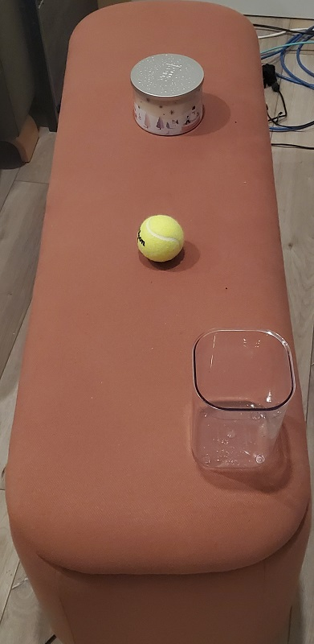

I put some objects on my ottoman to better meet the requirements of the project. There is a candle, a tennis ball, and a storage container as the complex object sitting on top of the ottoman.

I can make all of the items in the image in 3D, I think. The ottoman itself and the objects on the ottoman can be recreated in 3D using OpenGL.

The ottoman itself is a big rectangular prism/cube. Whose surface acts as a plane to ground the rest of the objects in the scene. The floor can also be a plane if I decide to include it. I don’t really want the background cords and floor in the scene. Ideally, I just have the ottoman and the objects on top of it. These objects are good choices because they represent the primitive shapes clearly.

The objects on top of it are the tennis ball is a sphere, the candle is a sort of cylinder, and the storage container is most complex is it is like a hollow rectangular prism. So I would need to use many shapes to make it, perhaps I could make the sides out of triangles to build its structure and it would remain hollow that way. These choices make sense as they are achievable within the object meshes I can work with.